Electronic Supplementary Material for the AVOCETTA paper:

Birds-of-paradise (Paradisaeidae) research: analysing research trends from 1862 to 2023
Hapiz Al Khairi ¹, Budi Setiadi Daryono ¹, Dwi Sendi Priyono ¹*, Fajar Sofyantoro ¹, Wahyu Aristyaning Putri ¹, Nur Indah Septriani ¹
Corresponding author: dwisendipriyono@ugm.ac.id

Table of contents:
Supplementary Figure 1. Document per year by the top 10 main source journals on BoPs research field, 1862-2023. The highest number of publications is by Emu, with a total of 38 publications.
Supplementary Table 1. The top 10 most productive countries in terms of BoPs research. The table shows a rank according to the total number of publications. The number, percentage, and citations of each country’s publications are also shown in the table.
Supplementary Table 2. The top 10 productive affiliations in terms of BoPs research
Supplementary Table 3. The top 10 productive and influential authors in BoPs research field
Supplementary Table 4. The top 10 funding sponsors in BoPs research field
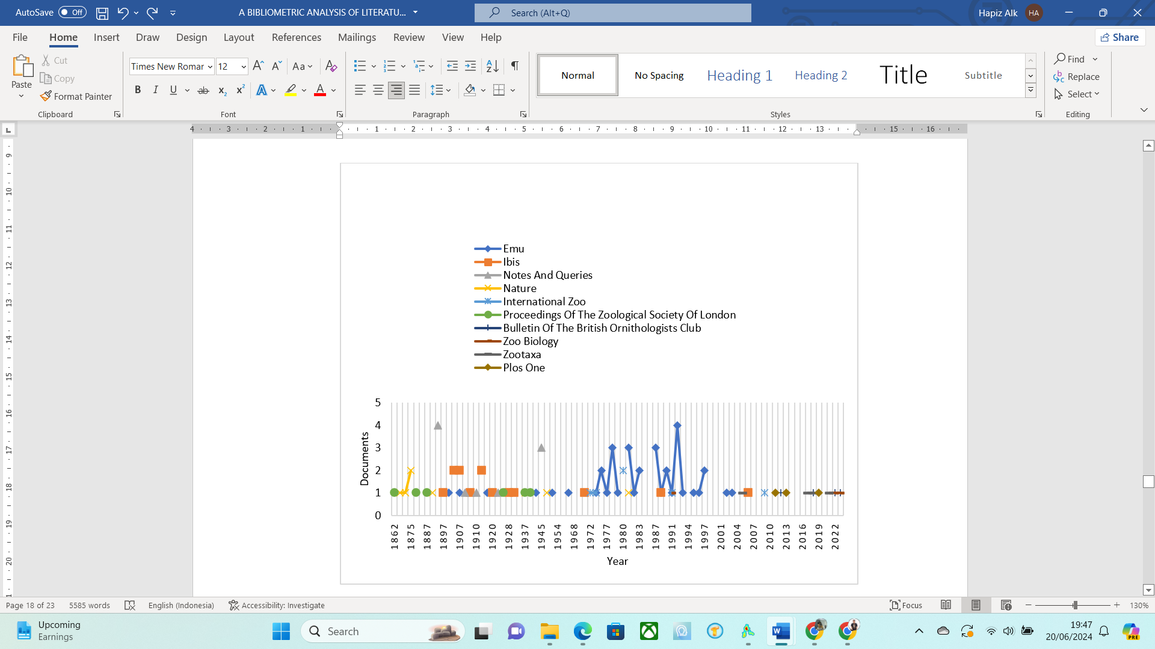
Supplementary Figure 1.

Supplementary Table 1.
Rank | Country | No. of Documents | Percentage | Citations | No. of Collaborating Country
1 | United States | 71 | 28.0% | 1471 | 11
2 | Australia | 44 | 17.3% | 422 | 9
3 | United Kingdom | 24 | 9.45% | 449 | 11
4 | Germany | 15 | 5.91% | 331 | 13
5 | Netherlands | 10 | 3.94% | 350 | 3
6 | Sweden | 10 | 3.94% | 253 | 11
7 | Papua New Guinea | 9 | 3.54% | 202 | 5
8 | Denmark | 6 | 2.36% | 246 | 9
9 | Indonesia | 6 | 2.36% | 86 | 9
10 | Brazil | 5 | 1.97% | 35 | 2

Supplementary Table 2.
Rank | Affiliation | Country | Number | Citations
1 | Naturhistoriska riskmuseet | Sweden | 9 | 251
2 | Cornell University | United States | 6 | 105
3 | Harvard University | United States | 6 | 132
4 | Cornell Lab of Ornithology | United States | 6 | 104
5 | Yale University | United States | 5 | 62
6 | American Museum of Natural History | United States | 5 | 261
7 | Smithsonian Institution | United States | 5 | 39
8 | Museum fur Naturkunde | Germany | 5 | 145
9 | Uppsala Universitet | Sweden | 4 | 162
10 | David Geffen School of Medicine at UCLA | United States | 4 | 112

Supplementary Table 3.
Rank | Author | Country | Number | Total
 |  |  |  | Citations
1 | Frith, C.B. | Australia | 16 | 140
2 | Frith, D.W. | Australia | 9 | 79
3 | Irestedt, M. | Sweden | 9 | 251
4 | Beehler, B.M. | United States | 6 | 34
5 | Scholes, E. | United States | 6 | 104
6 | Christidis, L. | Australia | 5 | 151
7 | Cracraft, J. | United States | 5 | 332
8 | Laman, T.G. | United States | 5 | 101
9 | Blom, M.P.K. | Sweden | 4 | 162
10 | Diamond, J.M. | United States | 4 | 25

Supplementary Table 4.
Rank | Sponsor | Country | Number | Type of Agency
1 | National Science Foundation | United States | 11 | Government
2 | Vetenskapsrådet | Sweden | 5 | Government
3 | Science for Life Laboratory | Sweden | 4 | Non-government
4 | New York Zoological Society | United States | 3 | Non-government
5 | Air Force Office of Scientific Research | United States | 2 | Government
6 | Australia Research Council | Australia | 2 | Government
7 | Georgetown University | United States | 2 | Campus
8 | Harvard University | United States | 2 | Campus
9 | Knut och Alice Wallenbergs Stiftelse | Sweden | 2 | Non-government
10 | National Geographic Society | United States | 2 | Non-government

